Tomcat installion
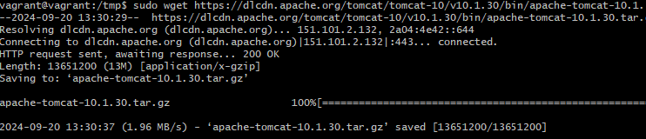

How to Install Tomcat 10 on Ubuntu 22.04 | Linuxize

